DIGITAL SIGNATURE APP
@CREATIVITY THINK (9483175986/7019689991)

ABSTRACT:
The Digital Signature App is a secure and efficient web-based platform designed to facilitate electronic document signing within organizations. It enables users to upload documents, generate or draw signatures, authenticate signers, and track approval status in real time. With role-based workflows for users and administrators, the system ensures accountability and traceability through complete signing logs and dashboard analytics. Built using Django and the Django Rest Framework on the backend, combined with React, Dropzone, and axios on the frontend, the application provides a robust digital signing experience suitable for offices, HR departments, legal processes, and contract approvals..

INTRODUCTION OF THE PROJECT:
Organizations increasingly rely on digital documents to streamline workflows, reduce paperwork, and expedite approvals. However, manual signing processes still cause delays, lack traceability, and depend heavily on in-person workflows. The Digital Signature App eliminates these limitations by offering an integrated electronic signing solution where users can upload documents, create signatures, apply them digitally, and track approval status without physical contact. Administrators oversee signing workflows, manage logs, and generate analytical reports. The result is a transparent, efficient, and secure digital signing process that improves organizational productivity..

PROJECT OBJECTIVES:

• To enable easy and secure uploading of documents for signing.
• To provide a user-friendly interface for creating, drawing, or uploading digital signatures.
• To automate the approval and signing workflow.
• To maintain complete signing logs for auditing and compliance.
• To offer a real-time dashboard for users and administrators.
• To reduce manual paperwork and streamline organizational processes.
• To support transparent, trackable digital signing operations.

PROBLEM OF THE STATEMENT:
Traditional document signing workflows often require physical presence, manual paperwork, and repeated verification. These processes are time-consuming, error-prone, and offer no centralized tracking mechanism. In addition, organizations face challenges maintaining signing authenticity and security. The Digital Signature App addresses these issues by providing a structured digital platform for document uploads, signature creation, secure approval workflows, and real-time status tracking. It significantly reduces overhead, increases transparency, and ensures secure document handling..

MOTIVATION OF THE PROJECT:
• To reduce dependency on physical signatures and manual documentation.
• To simplify and automate organizational contract and approval workflows.
• To ensure secure and authenticated document signing.
• To improve transparency through signing logs and audit trails.
• To enhance productivity by eliminating time-consuming manual processes.

BLOCK DAIGRAM OF PROJECT:

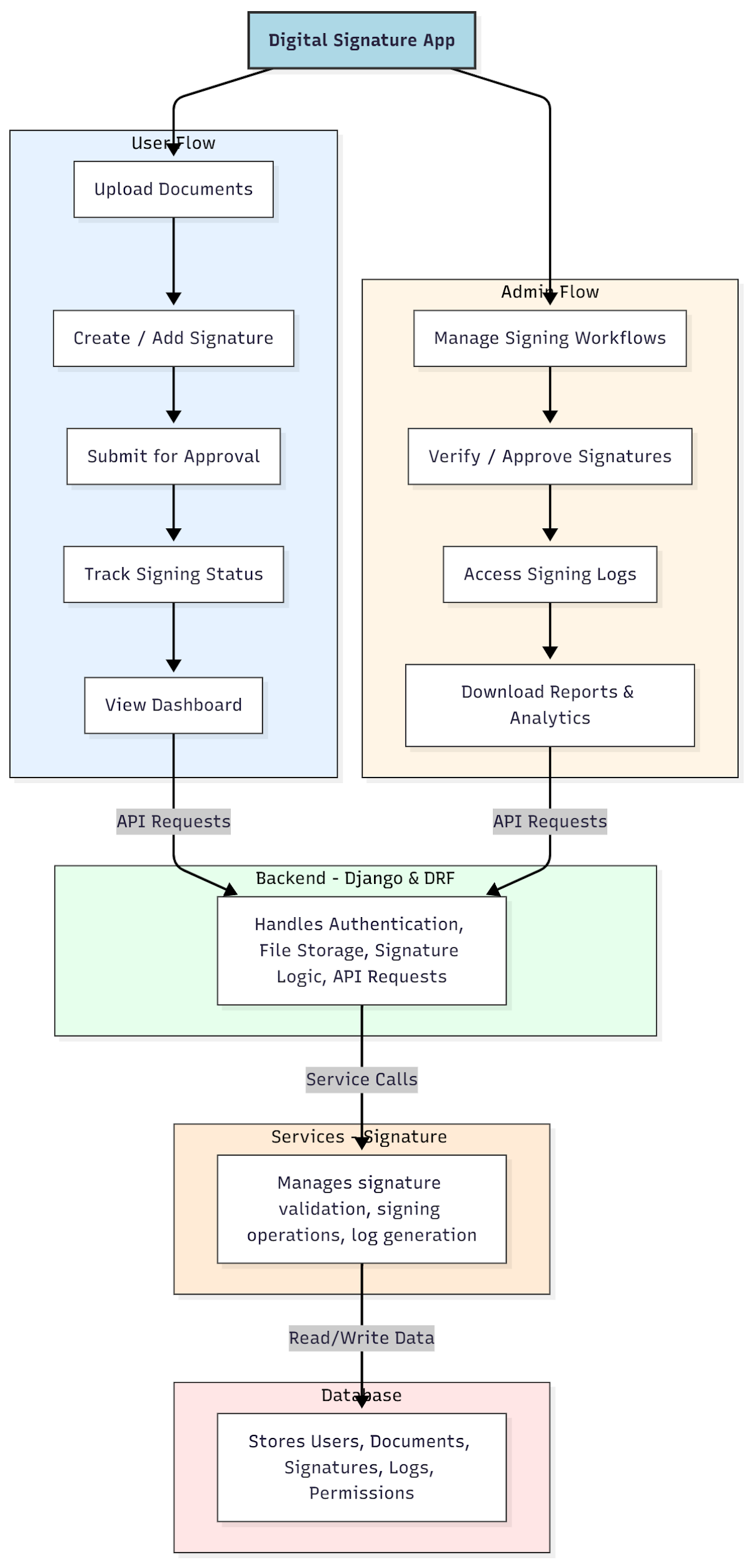

WORKING OF THE PROJECT:
The Digital Signature App operates through a secure and structured workflow. Users begin by uploading documents through a streamlined interface powered by Dropzone. After uploading, users create or provide a digital signature, which can be drawn, typed, or uploaded. The system associates the signature with the document and forwards it into the approval pipeline. Administrators review pending documents, validate signatures, approve or reject documents, and update the signing status. Signing logs are automatically generated, ensuring transparency and traceability. The backend manages authentication, file handling, and workflow logic, while the database securely stores documents, signatures, and approval data. Analytics and reports are presented through dashboards for both users and administrators, offering complete insight into signing activities..

SOFTWARE REQUIREMENT:
- Backend:
  - Python 3.x
  - Django
  - Django REST Framework
  - SQLite/PostgreSQL
- Frontend:
  - Node.js and npm
  - React.js
  - Axios
- Development Tools:
  - Visual Studio Code
  - Postman (for testing APIs)
  - Git/GitHub (for version control)
- Server/Deployment (Optional):
  - Gunicorn, Nginx, or Heroku/AWS for hosting

ADVANTAGES OF THE PROJECT:

• Eliminates manual paperwork and accelerates approval cycles.
• Provides secure and authenticated digital signatures.
• Offers complete transparency through detailed signing logs.
• Enables easy document uploads and signature creation.
• Reduces administrative overhead and improves workflow efficiency.
• Ensures compliance and accountability through audit trails.
• Provides dashboard analytics for monitoring document activity.
• Supports remote and contactless signing processes.

APPLICATIONS OF THE PROJECT:
• Office document signing workflow.
• HR policies, employee contracts, and onboarding documents.
• Legal and compliance-related digital signing.
• Contract approvals for vendors and clients.
• Internal document approvals within companies.
• Multi-level signing workflows for organizations.
• Secure record maintenance for audits and reporting.

REFERENCES:

- Django REST Framework Documentation — Django Software Foundation. Django Documentation. Available: https://docs.djangoproject.com/
- Django REST Framework. DRF Documentation. Available: https://www.django-rest-framework.org/
- React. React Official Documentation. Available: https://reactjs.org/docs/getting-started.html
- Redux. Redux Documentation. Available: https://redux.js.org/introduction/getting-started
- PostgreSQL Global Development Group. PostgreSQL Documentation. Available: https://www.postgresql.org/docs/
- MySQL. MySQL Reference Manual. Available: https://dev.mysql.com/doc/
- Git. Git Documentation. Available: https://git-scm.com/doc
- Node.js. Node.js Documentation. Available: https://nodejs.org/en/docs/
- Axios. Axios Documentation. Available: https://axios-http.com/docs/intro
- Socket.io Documentation – https://socket.io/docs/

